Rotary Club of Kathmandu Mid-Town
Breakfast Chatter



13 October 2006 The Weekly Bulletin of Rotary Club of Kathmandu Mid-Town Bc # 15 of 2006-07

District : 3290 Web: www.rotarymidtown.org.np Club Id : 26776

OCTOBER IS VOCATIONAL SERVICE MONTH
Vocational service is also a good way to assist young people in learning about future careers. Students can learn more about specific professions through interviews or job shadowing. Rotary clubs can contact their chambers of commerce and local companies to set up employee training, literacy training, employment counseling, résumé preparation, and other services to meet vocational needs.

Talk program on Urban Concern and Waste Free Communities
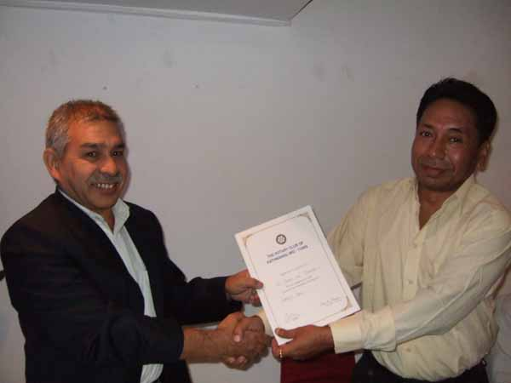
Actg President Subarna Joshi presented a Letter of Appreciation to
Guest Speaker Rtn Badan L Nyachhyon
for giving a talk at Club meeting on Friday 6 October 2006.

Weekly Meetings and Programs :
Date | Program/Speaker | Program/Topics of Presentation
13 October 2006 | Dr Bijay K C | Managerial challenges for development
20 October 2006 | Dr Isabella C B'nana Khadka | Past Reminiscences and Present Musings
27 October 2006 | Juergen Dahm | Helping poor children of Kathmandu

Friday, 13 October morning :
Prof Bijay Kc, Dean of South Asian Institute of Management, will be talking on managerial challenges for development in Nepal. He plans to deliberate on current scenario of economic development, major challenges we have been facing and how can we address this from the perspective of management. Prof Bijay has been involved in management education for more than 30 years and has developed expertise in areas of corporate finance, financial markets and institutions, investment, strategy and business policy. Prior to his current position at SAIM, Prof Kc served as Dean and Professor at the Kathmandu University, School of Management for ten years and as a faculty member in the Central Department of Management, Tribhuvan University for over twenty years.

Club Activity : Bowling
A bowling program jointly with Rotaracts of Kathmandu Mid-Town is scheduled to be held on Saturday morning, 14 October 2006. The venue is at Bowling Boulevard, Kantipath, adjacent to Restaurant 1905, Kathmandu. Come and join in the program either as a player, or simply watching as an observer ! The program starts at 09:00 hrs with tea/coffee and fellowship.

Handing Over of DG's Memento :
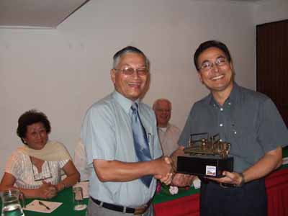
District Treasurer Siba B Rajbhandari (IPDS) handed over a memento to PP Mani D Joshi
on 22 Sept 2006 at the club meeting,
the memento awarded by DG Swapan Mukherjee during District Recognition Ceremony held in Kathmandu on 27 June 2006 for his contributions in District Award Ceremony and received recently.

Condolence :
CLE legend of Nepal Rotary Rtn Gilbert Singh passed away recently. Late Singh was providing unparalleled service to the needy women and children through CLE programs. He was indeed exemplary in providing his time and efforts in the true spirit of service above self, a Rotary theme which many enjoy talking rather than practising. The editorial team of Breakfast Chatter expresses its heartfelt condolence and deep sorrow to Mrs Singh and all bereaved family members.

Breakfast Chatter extends
CONDOLENCE
to Mrs Singh and the bereaved family members.

On Lighter Side : Click at the figure ⇩


We work people to people. And we need to think small, remembering that if we lift up the life of one individual, we have done something wonderful.
RI President William B. Boyd

13 October 2006 The Weekly Bulletin of Rotary Club of Kathmandu Mid-Town Bc # 15 of 2006-07

Editor: RR Shrestha, Club Service Director email: rryes@wlink.com.np

